3D Scanning Guitar
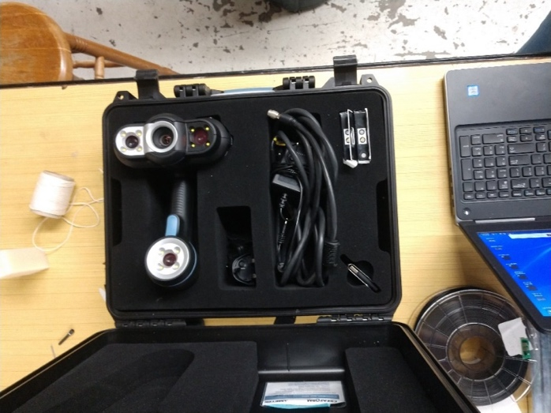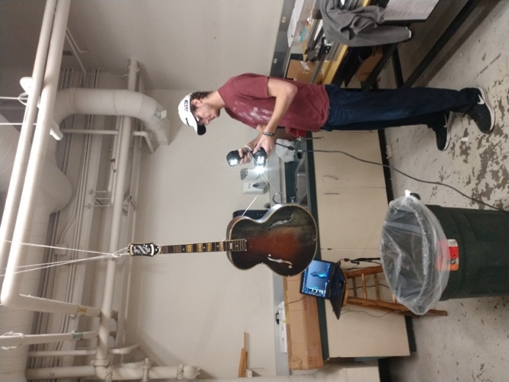
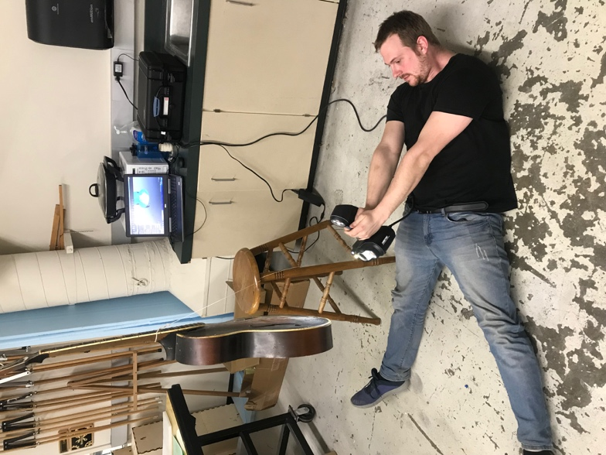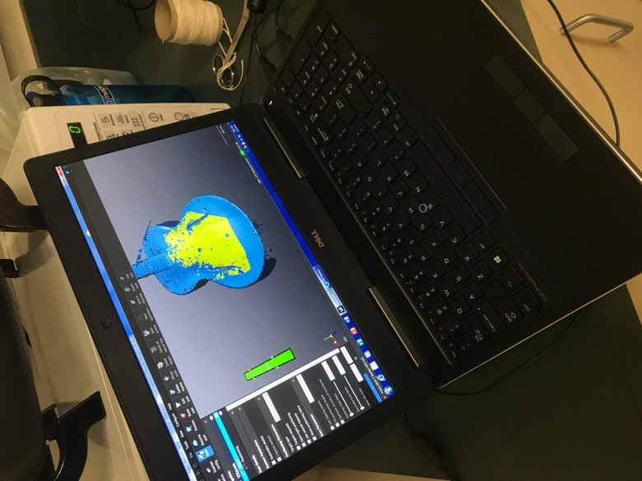
The first step of this project was to place stickers on the surfaces that have mild contours or are too shiny. These stickers help the 3D scanner make out these settle features. The next step was to scan the guitar making sure to scan the entire surface as complete as possible this will be greatly to the operator’s advantage when it is time to do the modeling
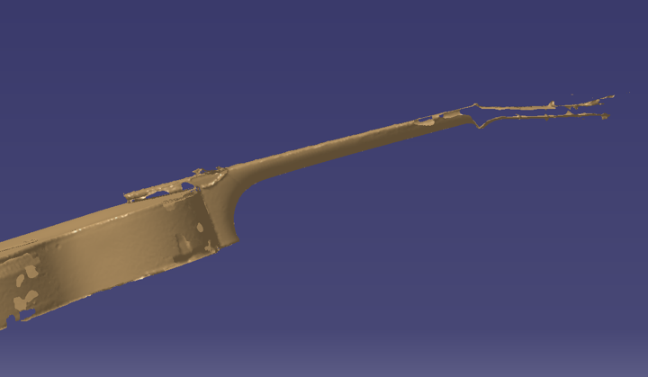
One of the key lessons we learned when scanning is to do your best to get a complete scan and try not to have any missing segments in the point cloud. Very small missing segments of the point cloud can be patched in CATIA’s Digitized Shape Editor workbench. However if you have large segments missing in the cloud, like at the headstock of the guitar picture above, then assumptions will have to be made due to the large missing segments. This will decrease the accuracy of the model. Assumption are guesses based upon geometry and visual aids.

Exporting 3D Mesh

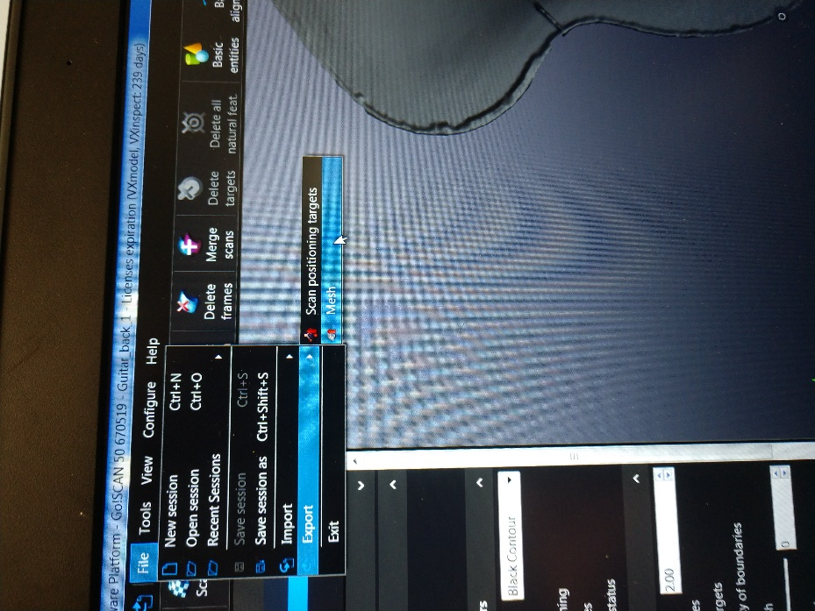
After the operator is satisfied with the scanned mesh it is important to export the mesh in a CATIA supported file type. This mesh was exported as an STL and imported into the Digitized Shape Editor Workbench.

Importing and Editing 3D Mesh

After the mesh is imported into the Digitized Shape Editor Workbench it will appear something as a light brown color. Now every point in the mesh can be selected as a point and more points can be added for modeling purposes.
In the Digitized Shape Editor workbench. This workbench allows the user to be able to edit the mesh. Such features like deleting, repairing, filling in missing gaps are available in a variety of ways. CATIA offers various ways to select and manipulate the mesh within this workbench. The more time spent here editing and fixing the mesh the more accurate and easier the surfacing will be. For our project we had to delete part of the string that held the guitar up that the scan picked up. We also used the fill gaps feature and filled in the small missing segments.

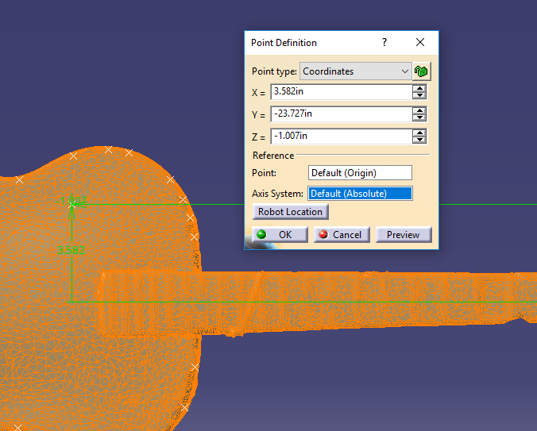

This is the Point feature located in the Generative Shape Design workbench within the Shape tab. This feature allows the user to place points directly on the point cloud (3D scan) the settings to do so are located in the picture above. Once in the Point tool and the settings above selected then the user can simply select any point on the point cloud. This feature can be very useful. For example if the user wants to create a plan in a unique geometry then the user can place 3 points on this surface and is then able to use the Plane tab and create the said plane on the difficult geometry.

Guitar Top Process

Step 1
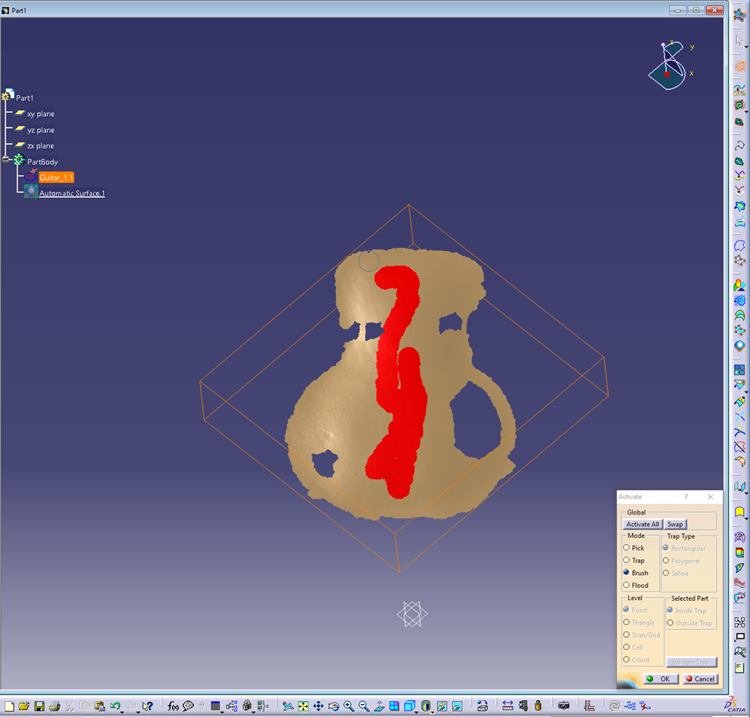
Now move the mesh by selecting the name at the top of the design tree. In this case it is Part1 and then go to the Quick Surface Reconstruction (QRS) Workbench. In this work. At the top of the tools the right-hand side there is a highlighted tool called the Activate tool. Select the Activate tool, in the dialog box select the Brush tool. Then paint the desired surface for reconstruction it can been seen in the above picture as the red lines. There can be holes left in the surfaces but make sure that all edges are connected.

Step 2
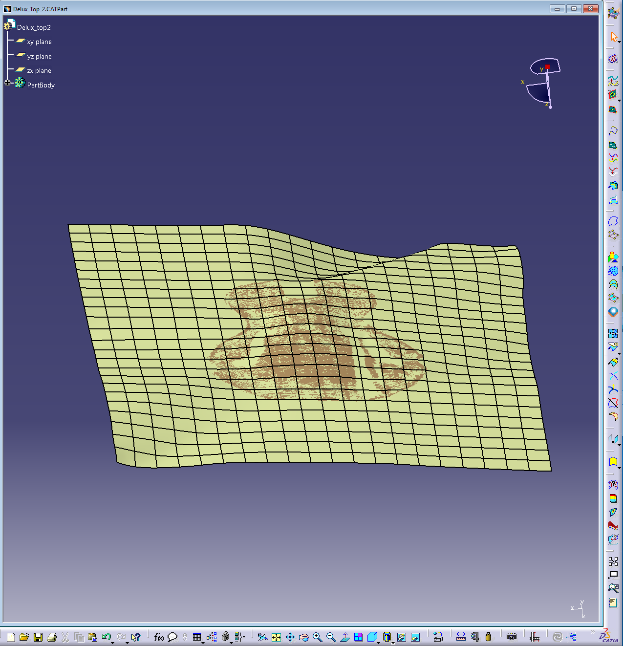
Remaining in the Quick Surface Reconstruction (QRS) Workbench select the 18th symbol from the top on the right-hand side it is called the Automatic Surface tool. In the dialog box select: Full internal tangency, Fill holes, Extended Surfaces. This generates an infinite plane that approximates the desired surfaces.

Step 3
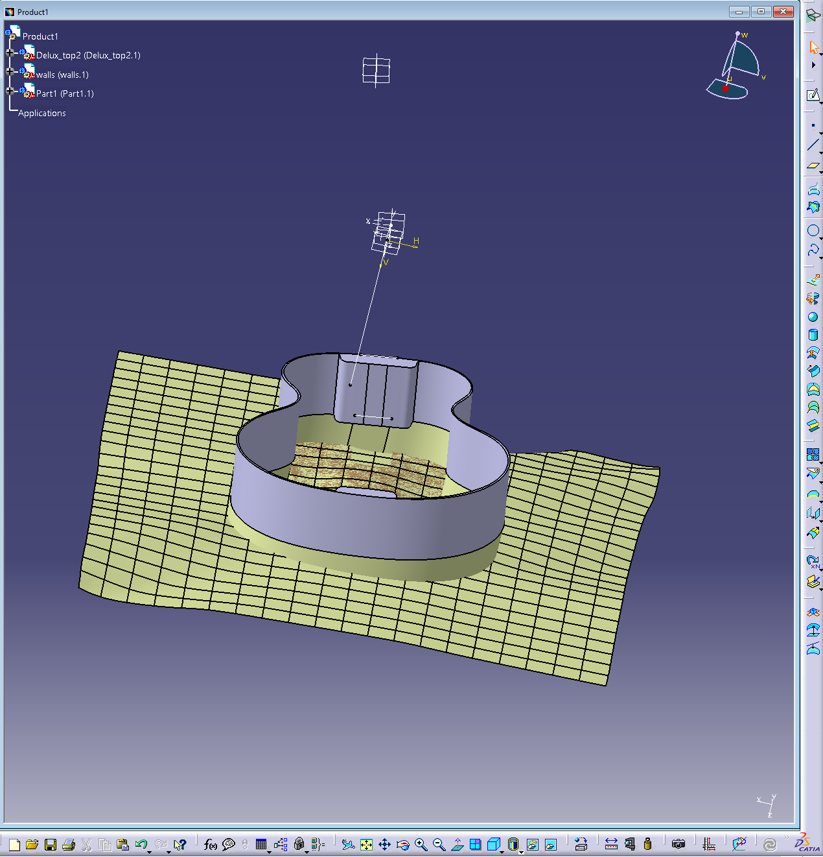
Then move to the Assemble Design work Bench. For this design the walls of the guitar were imported. However, it is important to make the walls and the surface as parallel otherwise the shape will be a similar shape but not exact.

Step 4
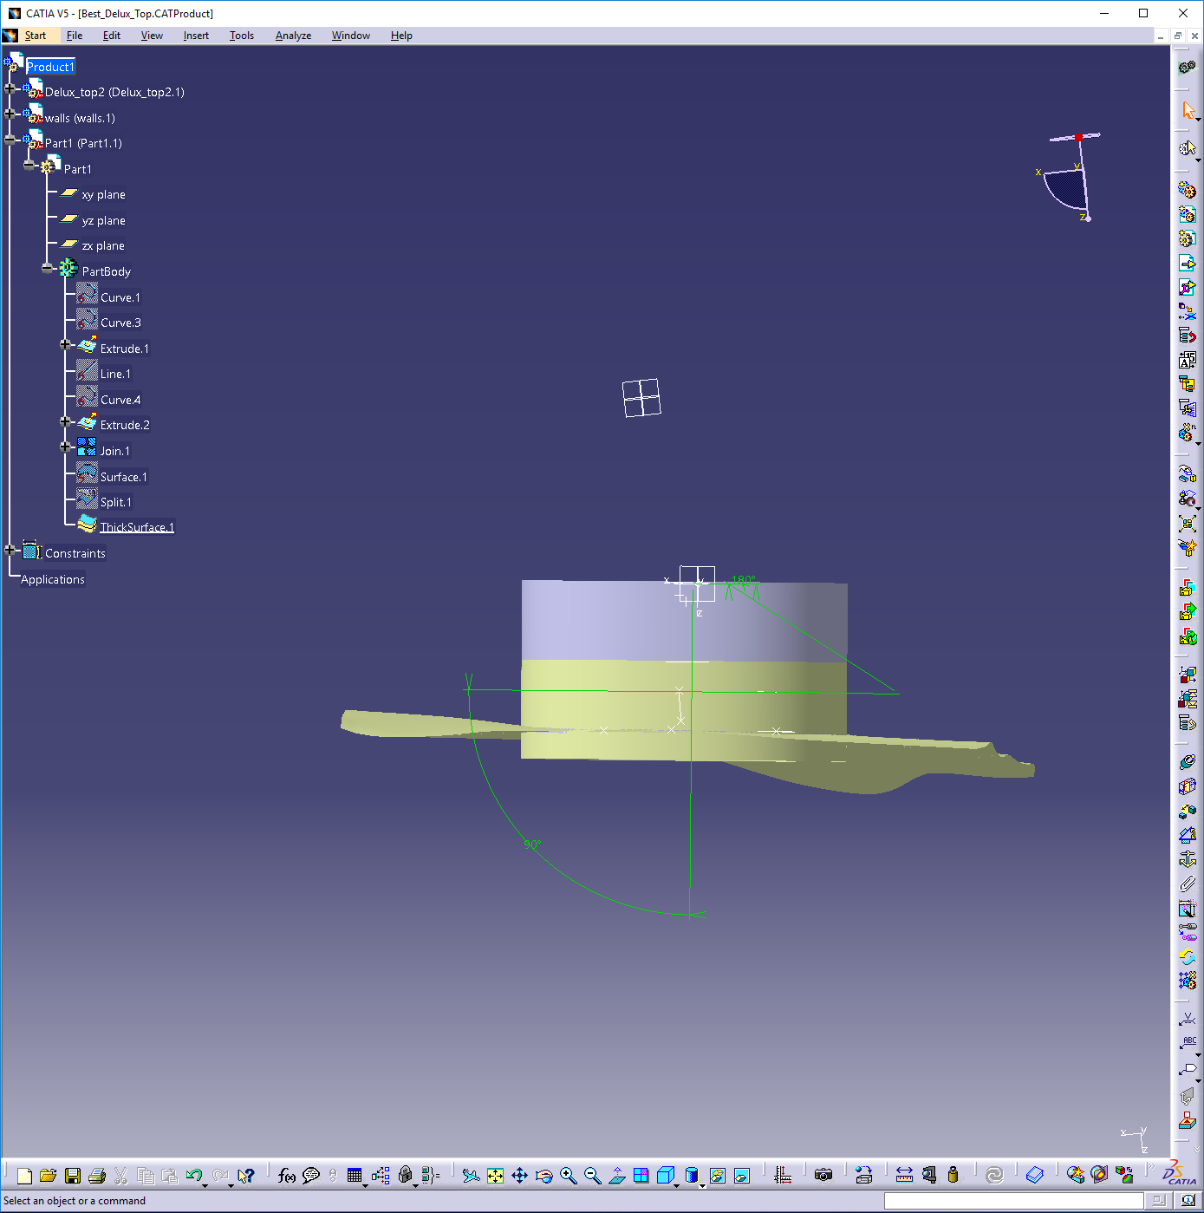
In order to, make them as close to parallel use angle mates on as many planes as possible.

Step 5
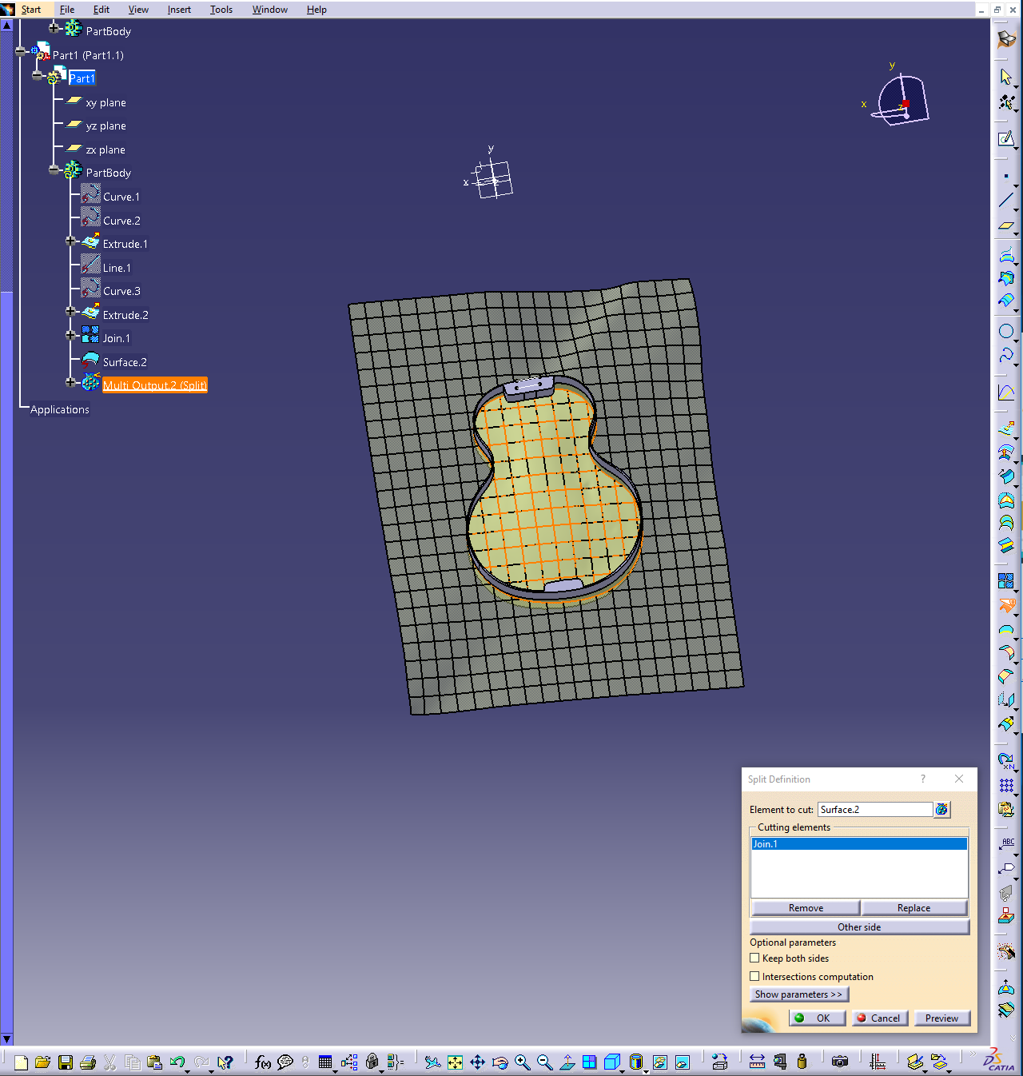
Then move to the Generative Shape Design Workbench and extrude the profile of the guitar. The extrude the walls as a surface passing through the surface of the top. Then use the split tool to cut out the guitar top shape.

Step 6
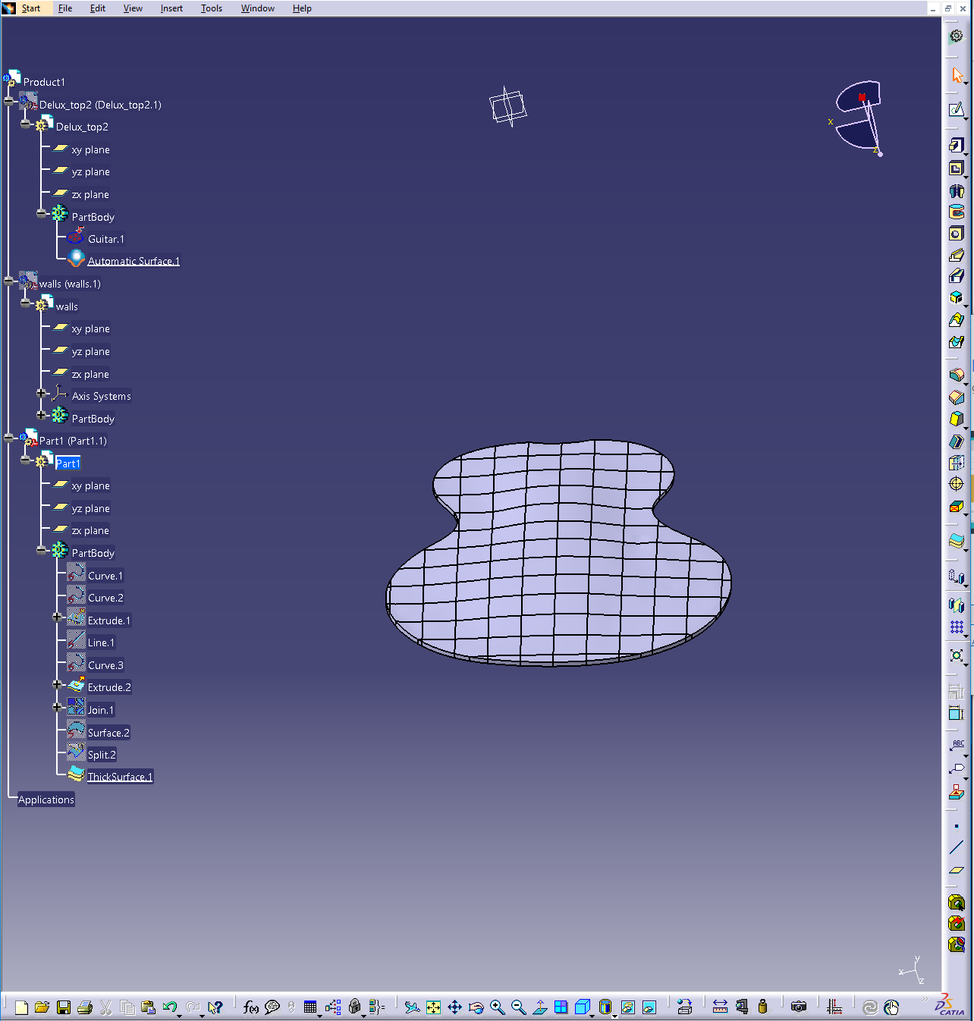
The next step should resemble the top of an arch top guitar. However, the f-holes are not cut out of the thickened surface and for simplicity the f-holes should be cut out of a surface instead of a solid.

Step 7
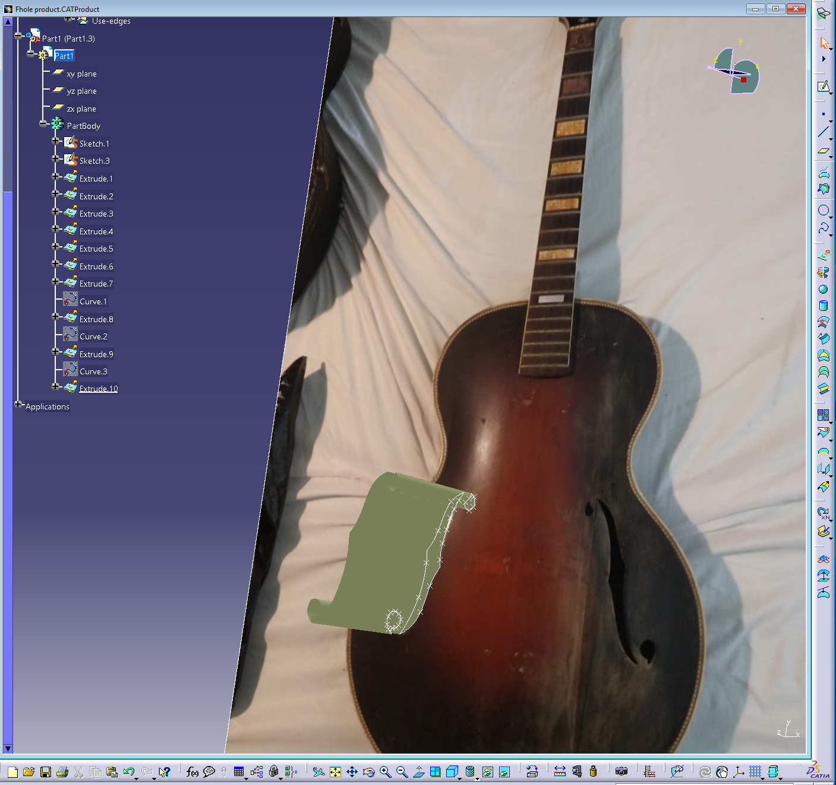
From the 3D scanner the resolution around the f-holes was not good enough to accurate enough to display the details of the f-holes. it was decided the Sketcher/Tracer Workbench would be used to model this feature. First mover to the Sketcher/Tracer Workbench then import a picture onto the desired plane. Then scale the picture to the desired size. Next open a sketch over the picture and trace the feature selected for modeling. Then move to the Part Design Workbench and extrude the sketch into a surface.

Step 8
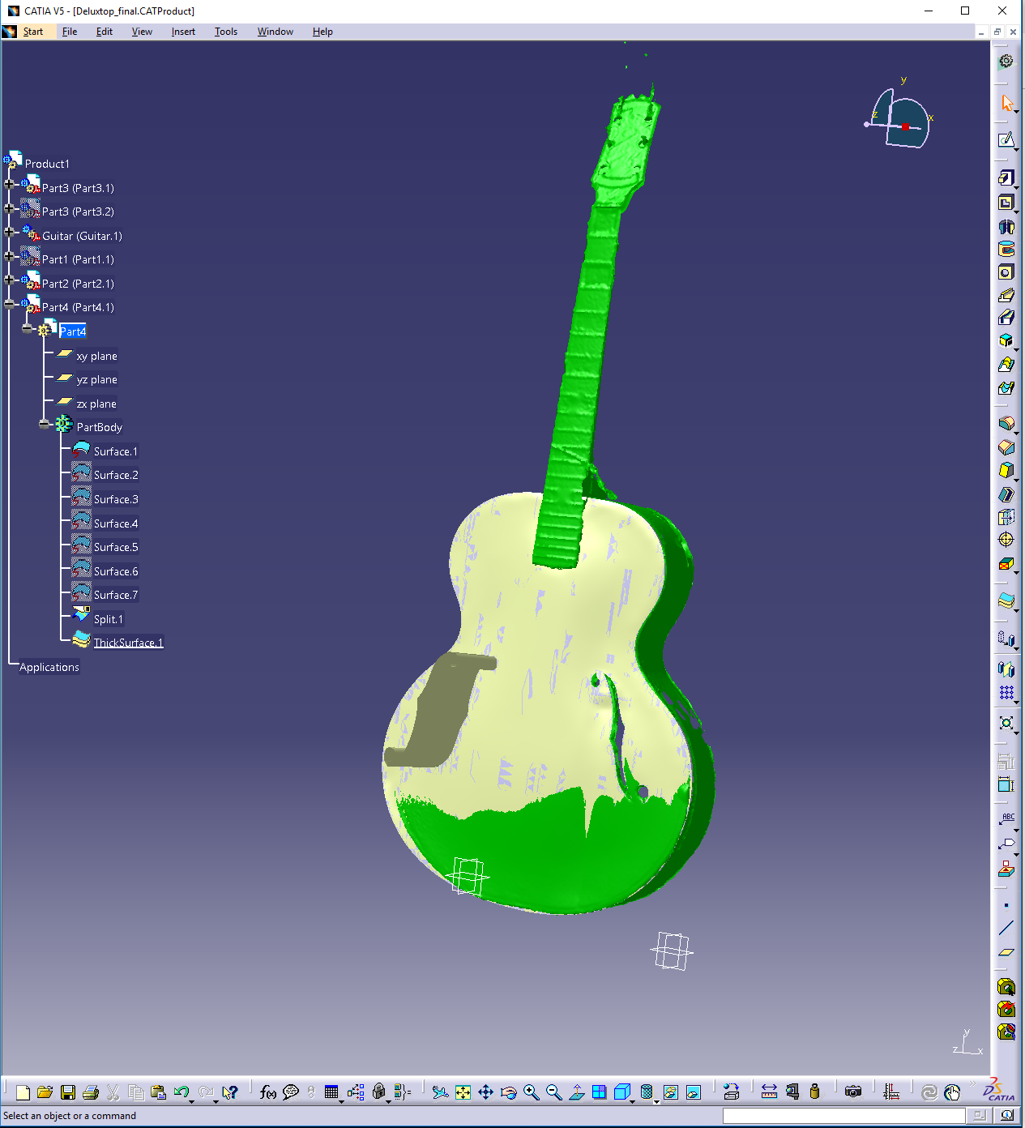
Next, open an Assembly Design work bench insert the guitar top surface, the f-hole surface and the 3D scanned mesh. Use the mesh to line up the f-hole on the guitar top surface. Then move to assembly to the Generative Shape Design Workbench and use the split tool to make the f-holes.

Step 9
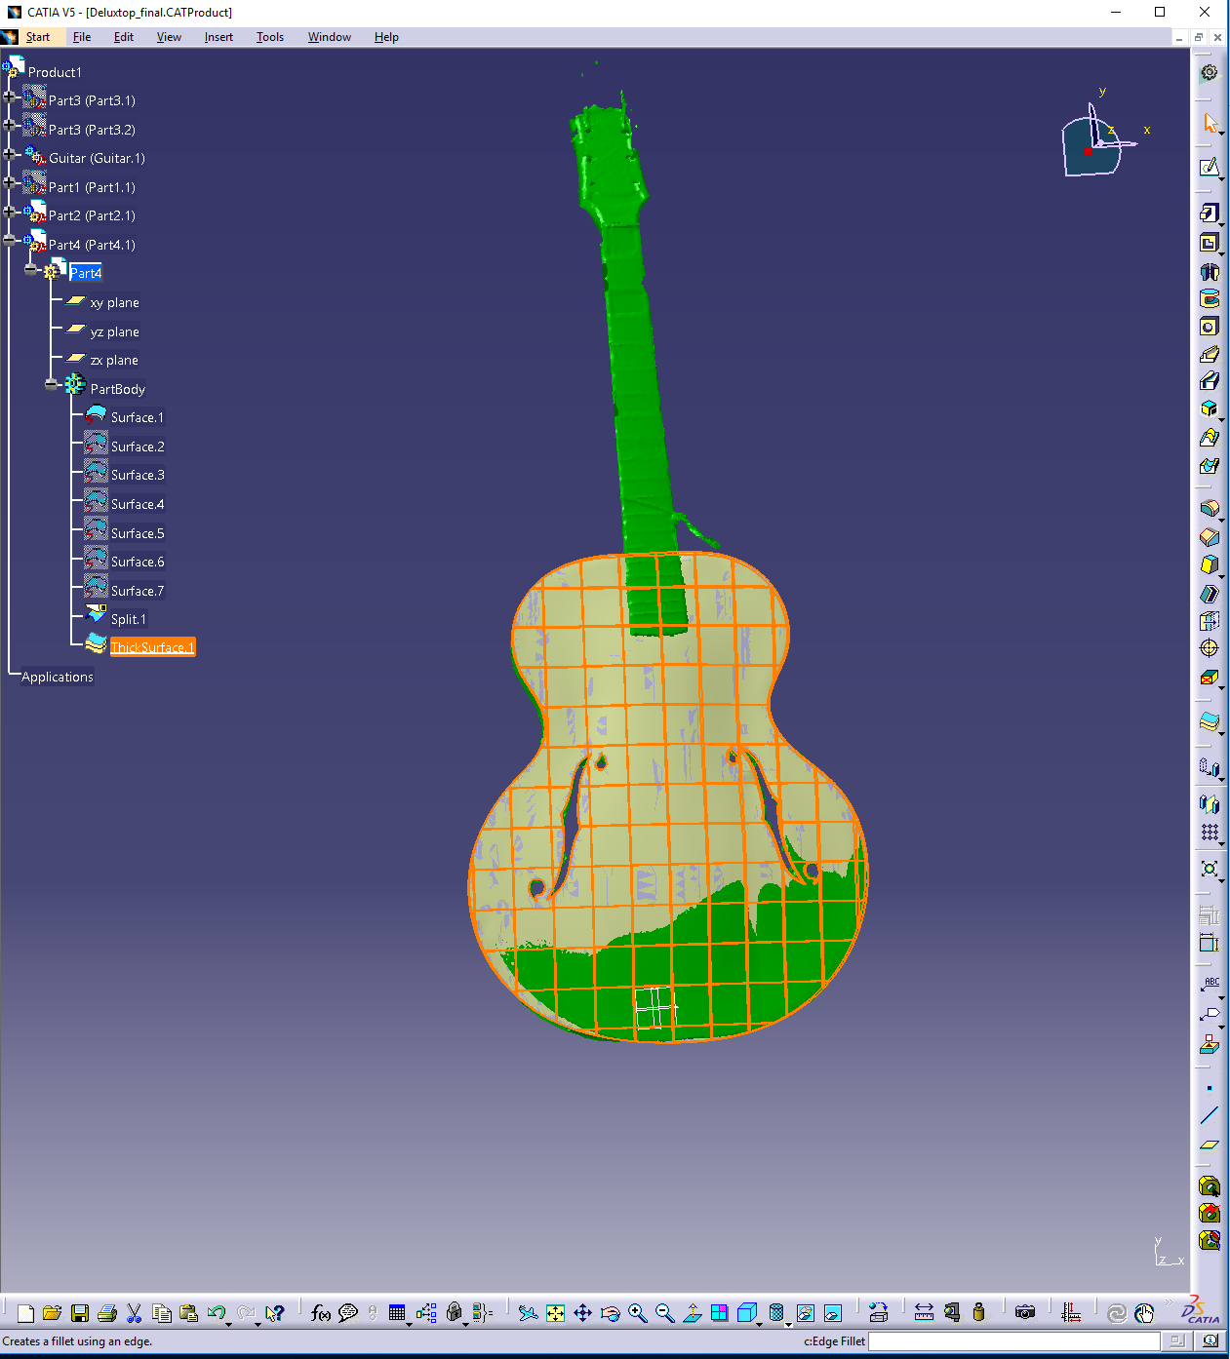
Removed f-hole top surface.

Step 10
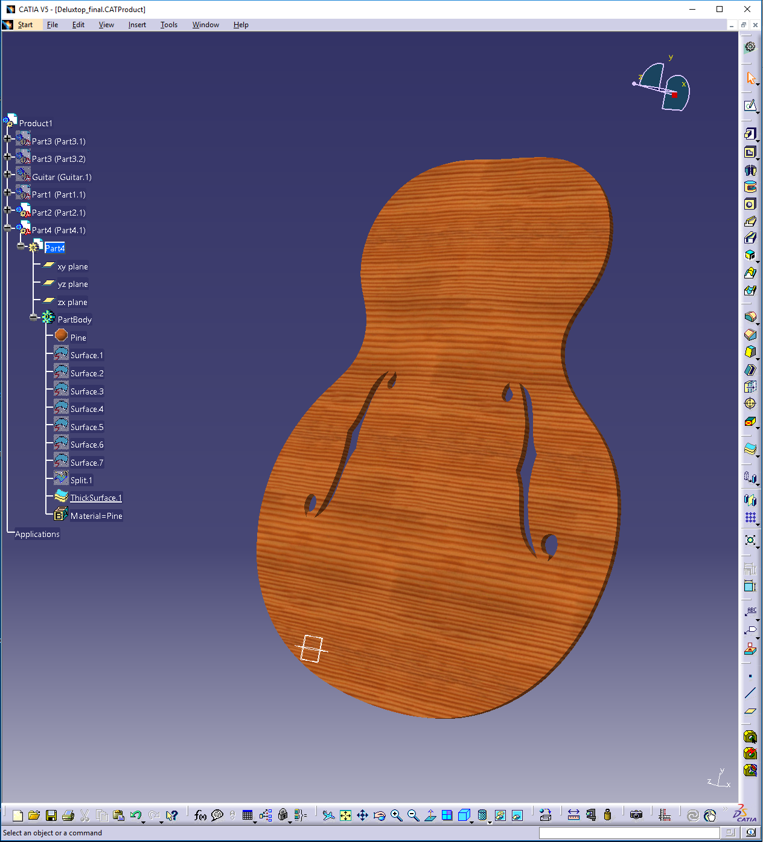
Then save the Product and make sure to save the new part created from the Assembly Workbench. Move the new surface to the Part Design Workbench and use the thicken surface tool to turn a surface into a solid part.

Guitar Back
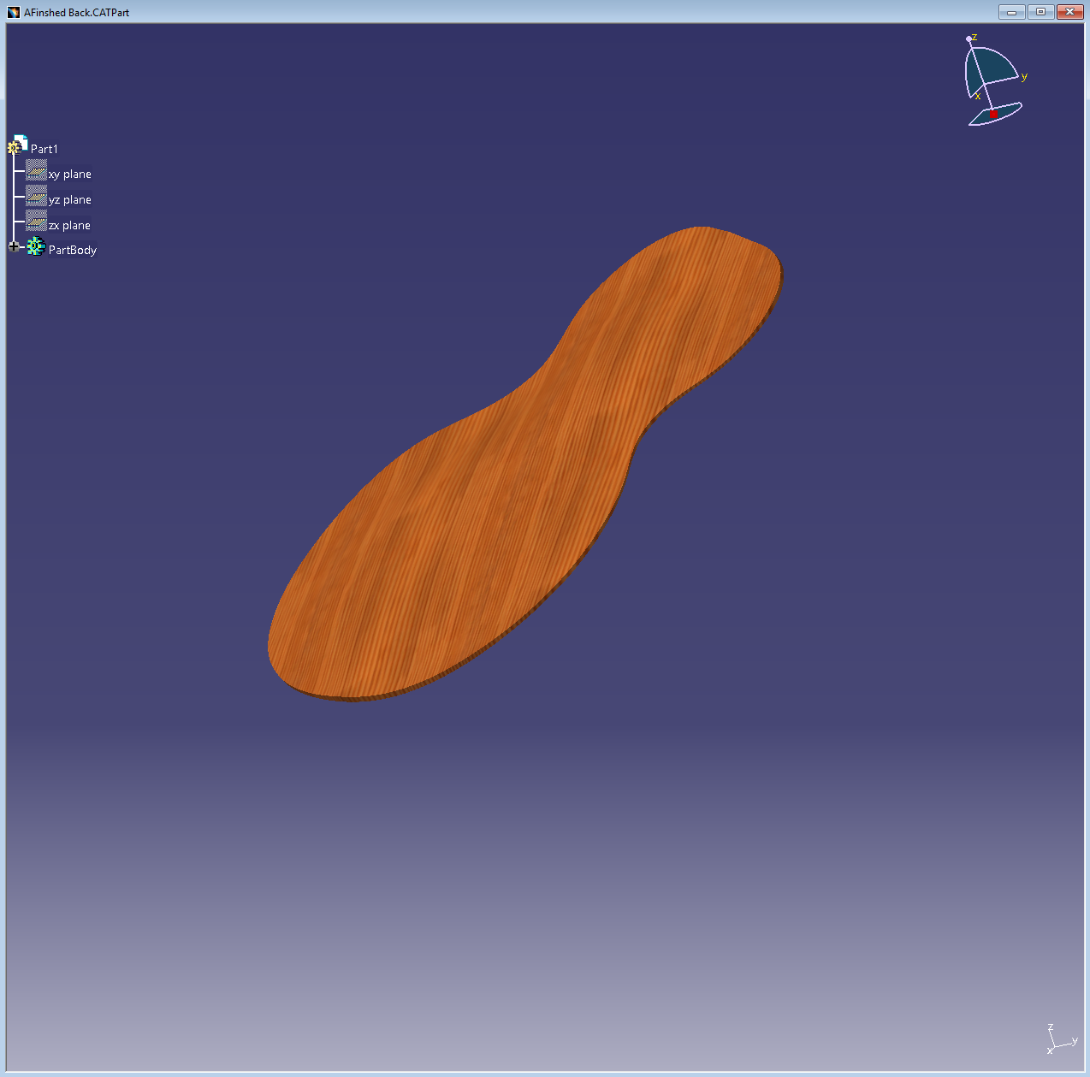
Note: The guitar back was created using the same process as the guitar top.

Guitar Walls Process
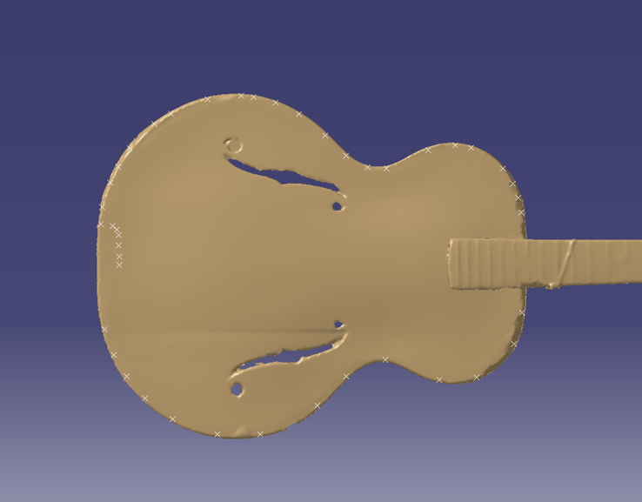
To model the guitar walls shape and thickness correctly we creating a spline around the outside of the guitar by placing points on the point cloud and then doing the inside of the guitar with the same technique. We needed a way to get the correct depth of the walls and be able to allign the walls with the point cloud. To do this we created a plane on the bottom surface of the guitar and on that plane we opened a sketch and 3D projected the two splines that represent the inside and outside profiles of the guitar walls. Lastly, we used the extude feature in the part design workebench to reach the desired depth of the guitar.
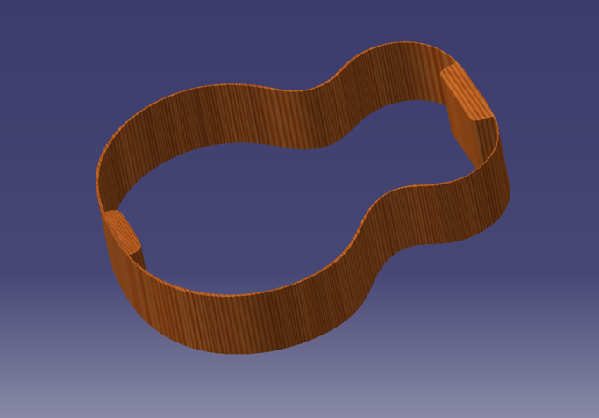
Final product of guitar walls.

Guitar Neck and Headstock

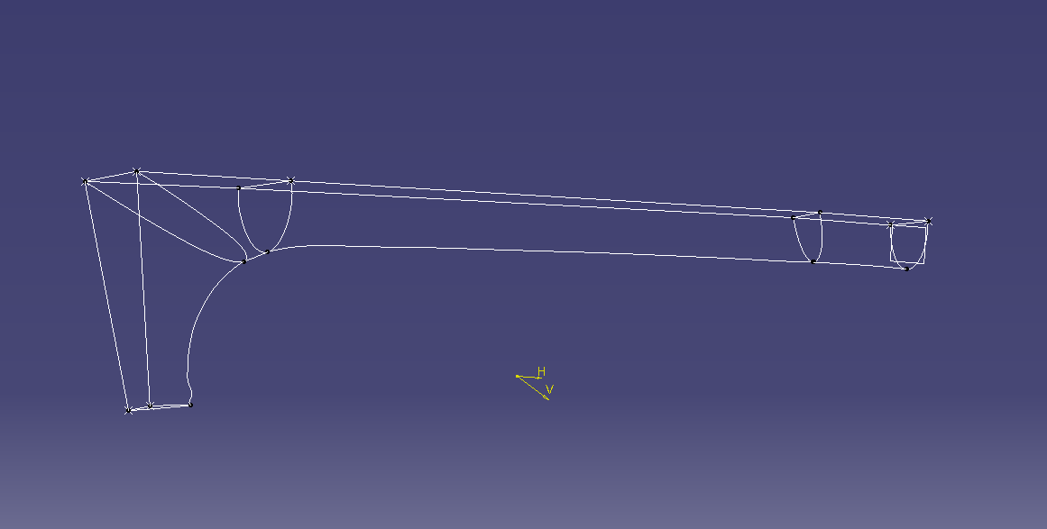
The photo above shows the sketches that outline the edge of the point cloud. These sketches were made from points placed on the point cloud and then splined and 3D projected to create the shell of the neck. Creating the model from these sketches will increase the accuracy of the model. We 3D lofted the solid model from sketch to sketch using the guidelines in place.

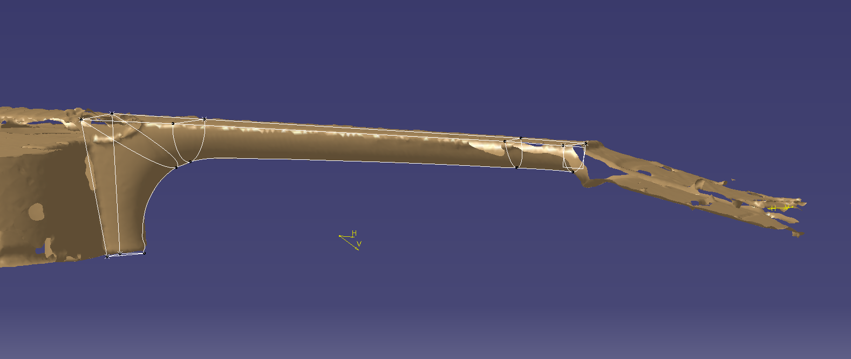

This is the shell of the neck overlaid with the point cloud to show the accuracy the model had.

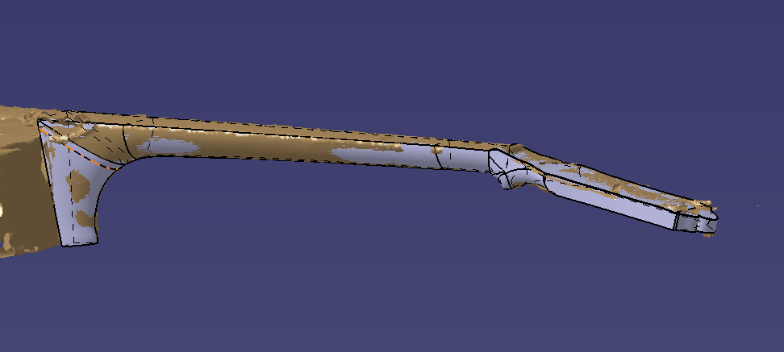
Lastly, this picture shows the 3D model overlaid with the mesh..

